|  |
| --- |
| MTU Kerry |
| Artificial Intelligence: Genetic Algorithm to Complete a 2D Platformer Level. |
| Academic Year:2024/2025  Programme Title: Computing with Games Development – MT803  Module Title: Artificial Intelligence  Module Code: COMP 81000  Lecturer’s Name: Robert Sheehy |

|  |
| --- |
| STUDENT Billy Elsbury |

Contents

Genetic Algorithm: 3

Brainstorming For Genetic Algorithm: 3

The Problem (~30%) 3

Description of the Problem 3

Discussion of the Suitability of Genetic Algorithms 3

Complexity of the Problem 4

The Problem and the Cost Function (~20%) 4

Fitness Function Code 4

The Individual (~30%) 5

Chromosome Representation 5

Crossover 5

Mutation 5

Code for Individual Class 6

Running the Algorithm (~10%) 7

Parameter Choices 7

Genetic Algorithm Execution Code 8

Results and Conclusions (~10%) 9

Results 9

Challenges and Limitations 9

Conclusions 10

Future Directions 10

Issues Discussion 10

Unity Project Creation Process: 12

C# Genetic Algorithm Explanation 12

Genetic Algorithm Running Demonstrations 14

Genetic Algorithm Replay Function Demonstration 16

Other Complete Examples that wouldn’t replay quite right 17

Conclusion 20

List of Figures 21

References 22

# Genetic Algorithm:

GitHub: <https://github.com/Billy-Elsbury/2D-Platformer-Unity>

## Brainstorming For Genetic Algorithm:

**Pathfinding for 2d platformer:**

*Could I make/find a platformer in Unity and then put in my own best time and aim to have the algorithm beat my time?*

**Problem**: Generate a set of inputs that will get a character the furthest in a 2d platformer game.

**Modifiers**: fitness cost could be determined by how far the character gets in the level, time taken, and number of obstacles avoided. There could be a slight penalty for jumping to discourage unnecessary jumping.

**Chromosome:**

A sequence of actions for the character to input, left right, jump. More?

The time delay between inputs would be represented in the chromosome.

**3 bands or channels with on or off for each keypress**

cost function related to the closest distance to the goal.

if (newDistance < bestDistance){bestDistance = newDistance}

**Crossover:** Combining segments of actions/inputs from two-parent solutions to create offspring.

**Mutation:** Randomly altering actions/inputs to find new possibilities/shortcuts.

# **The Problem (~30%)**

## **Description of the Problem**

This project applies a **Genetic Algorithm (GA)** to train an AI agent to move efficiently through a level in **Unity**. The AI controls a **player character** that can move left, right, and jump. The objective is to optimise movement such that the AI reaches the goal as quickly as possible while navigating the level safely.

The AI learns by evolving movement sequences (chromosomes) across multiple generations, with the best chromosomes being selected for further refinement.

## **Discussion of the Suitability of Genetic Algorithms**

A Genetic Algorithm is suitable for this problem because:

* The search space is large, as movement sequences can vary in timing and direction.
* A **deterministic approach** (e.g., brute force or traditional search trees) would be computationally expensive due to the number of possible movement combinations.
* GAs allow for **continuous optimisation**, evolving better movement strategies over time.
* The problem has a **clear fitness function** (distance travelled + goal completion time), making it easy to evaluate individuals.

## **Complexity of the Problem**

This problem is moderately complex because:

* The AI needs to determine **when** and **how long** to move or jump.
* The physics engine introduces variability in movement outcomes.
* The agent must **balance exploration and exploitation** to avoid suboptimal behaviours.
* A **suitable fitness function** is critical to prevent unintended behaviours (e.g., idling or dying at the right time).

# **The Problem and the Cost Function (~20%)**

## **Fitness Function Code**

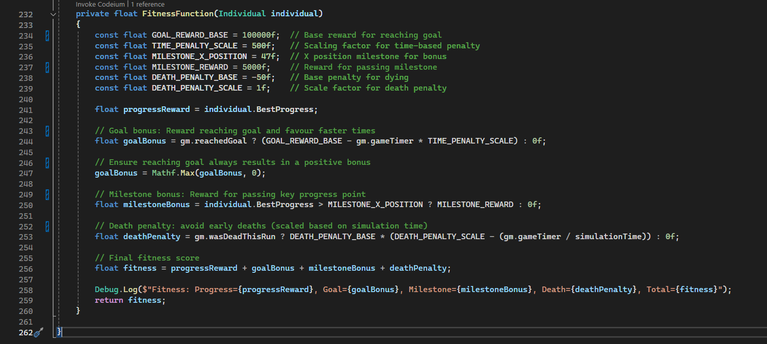

# **The Individual (~30%)**

## **Chromosome Representation**

The chromosome is a **floating-point array (**Figure 1**)** representing a sequence of movement actions. Each gene in the chromosome corresponds to an action (left, right, jump) with the value of the floating point number representing the time to hold that input.



Figure 1: Chromosome Example

## **Crossover**

A **blend crossover** is used, where two parent chromosomes generate offspring by mixing their genes with some exploration variability.

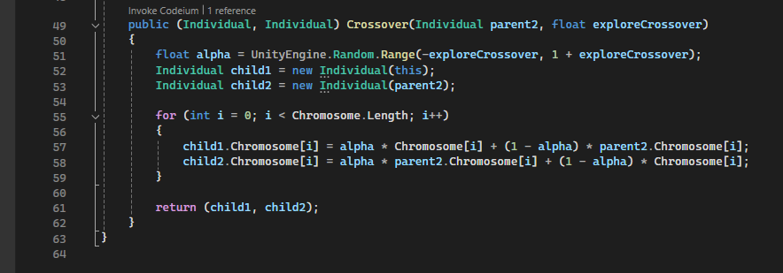

## **Mutation**

A small mutation is applied to **introduce randomness**, preventing the algorithm from converging too early.

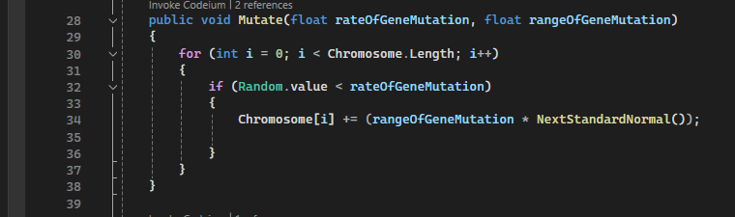

## **Parent Selection**

The SelectParent function implements Tournament Selection with a tournament size of 3. It works by:

* Randomly picking 3 distinct individuals from the current population.
* Comparing their fitness (Cost).
* Selecting the individual with the highest fitness out of those 3 as the parent.

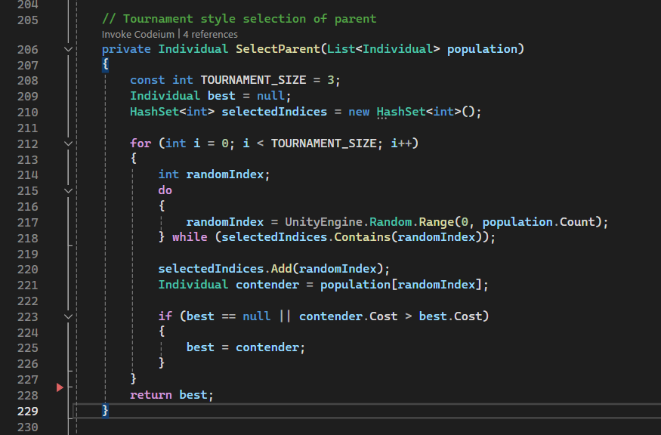

## **Code for Individual Class**

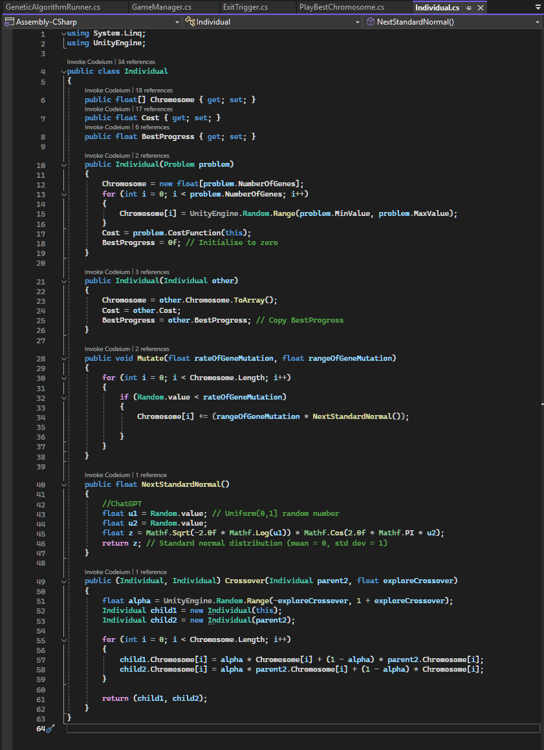

# **Running the Algorithm (~10%)**

## **Parameter Choices**

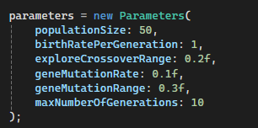

* **Population Size = 50** → Larger population will improve accuracy but take longer.
* **Crossover Exploration = 0.2** → Ensures meaningful genetic diversity.
* **Mutation Rate = 0.1** → Prevents premature convergence.
* **Mutation Range = 0.3** → Only alter inputs minutely -0.3 to 0.3 seconds.
* **Max Generations = 10** → More generations will improve accuracy but take longer.

## **Genetic Algorithm Execution Code**

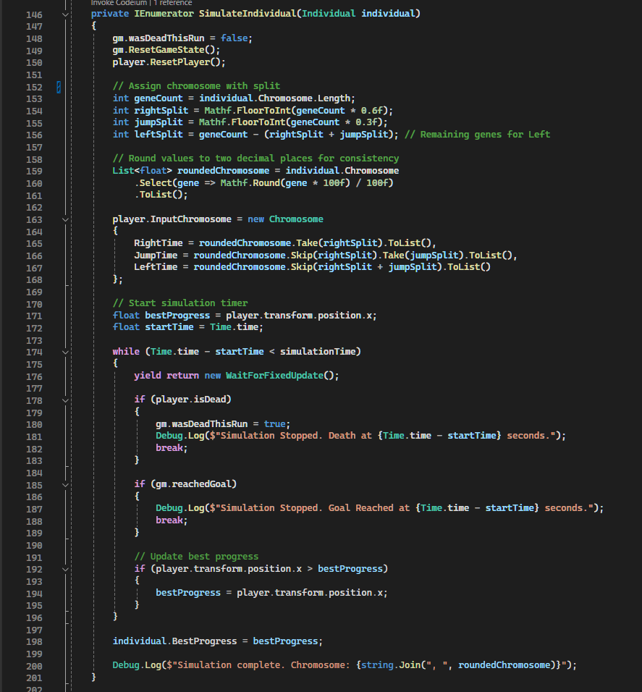

# **Results and Conclusions (~10%)**

## Results

* **Progressive Improvement**: Over 10 generations, the AI demonstrated marked progression in navigating the level. By Generation 10 (Figure 6) the AI consistently reached advanced sections of the level, compared to minimal progress in Generation 1 (Figure 5).
* **Fitness Function Efficacy**: The progress-based fitness function successfully incentivised fast right movement. However, subtle adjustments, such as reducing penalties for late deaths, inadvertently encourage overly safe behaviour (Figure 3), highlighting the complicated nature of the fitness criteria.
* **Parameter Impact**:
  + A **mutation rate of 0.1** and **crossover exploration of 0.2** balanced exploration and exploitation, preventing premature convergence while refining viable strategies. In initial tests, these values were higher but led to too many alterations and good runs being negatively altered.
  + A **population size of 50** provided sufficient diversity without excessive time, initially a population of 100 was used with a game speed of 20-50x but this caused inconsistencies in the replay function and seemed to cause inaccuracies in the runs. As such as smaller population run at 2x-10x game speed was used for testing.
* **Goal Achievability**: While the AI did not surpass the human baseline (12.73 seconds)(Figure 4) in my testing, it consistently achieved a best completion time of below 30 seconds (**Error! Reference source not found.**), demonstrating the achievement of a Genetic Algorithm in completing a 2D platformer level, while also highlighting the possibility of further optimisation to closer compete with a human run.

### Challenges and Limitations

* **Fitness Function Sensitivity**: Minor changes to the fitness function led to unintended behaviours: e.g. overly safe strategies, underscoring the need for iterative testing and a layered fitness reward structure.
* **Physics Inconsistencies**: Rigid body calculations at high simulation speeds, over 10x game speed, caused inconsistencies in chromosome simulating and replay outcomes, reducing reliability.
* **Success Direction**: In testing, some runs used suboptimal movement patterns (e.g., excessive jumping, backtracking). A solution such as dynamic mutation rates could mitigate this issue.

### Conclusions

This project validates genetic algorithms as a viable method for 2D platformer AI training while emphasizing the importance of careful fitness design and parameter calibration. With refinements, this Genetic Algorithm approach could rival or exceed human performance benchmarks.

* **Fitness Design**: Reward structures must be tested to align AI behaviour/ improvements with desired outcomes.
* **Parameter Tuning**: Small adjustments to mutation and crossover rates significantly impact alterations of individuals.
* **Physics Stability**: Deterministic simulations are crucial for reliable chromosome evaluation, and ensuring movements are calculated in fixed updates at a reliable game speed is crucial.

### Future Directions

* **Multi-Objective Optimisation**: Include coin collection, back-tracking avoidance and obstacle avoidance as explicit fitness criteria.
* **Enhanced Replay Stability**: Reavulate frame-independent physics to ensure consistent chromosome simulation.
* **Adaptive Parameters**: Self-adjusting mutation rates based on population metrics could improve evolution speed.

## Issues Discussion

Quick Issue: Genetic Algorithm won’t play in the the editor when not focused. [Solution](https://discussions.unity.com/t/keep-editor-playing-when-not-in-focus/820993)  
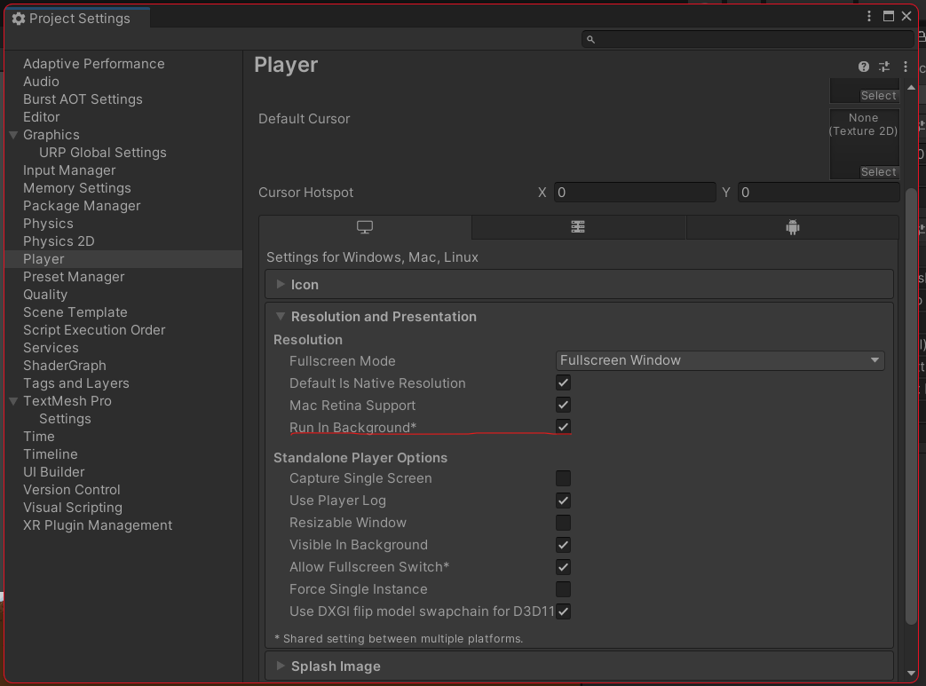

The genetic algorithm is tricky as encouraging and discouraging certain aspects can massively impact the behaviour of the AI. An example is when the fitness function (Figure 2) was configured to not punish dying late as harshly. This was intended to encourage the AI to still make progress without being discouraged so harshly for dying at the end of a good run. This had the unexpected result of encouraging the AI to run about the beginning of the level where it is safe until the time limit was nearing the end, and then attempting to make progress. Examples such as these demonstrate how a small tweak in the fitness function variables can cause rippling effects after many generations of training.

(Figure 3) Shows the replay function with the best Chromosome after 10 generations with 50 individuals in each generation. This displays how the AI did not make any progress until the very end of the Time limit (90 seconds).

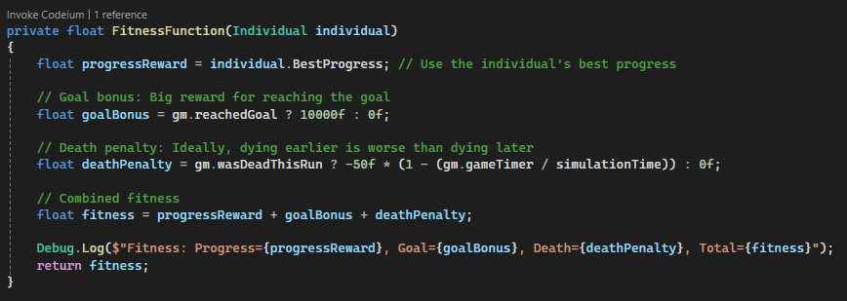

Figure 2: Fitness Function, later death example



Figure 3: Best Chromosome with late death fitness

**Issue:** Inconsistency with replay function. The same chromosome can result in different outputs. Rigid body calculations may be inconsistent at such high game speeds.

# Unity Project Creation Process:

A general genetic algorithm Python script (Sheehy, 2025) was used as a basis for this project. Initially, it was planned to integrate the Python genetic algorithm with Unity. There are ways to do this such as embedding Python into Unity using Iron Python (IronPython.net, 2025) (Unknown, 2013). However, this process is quite dated and not widely used or tested on modern versions of Unity. Another alternative would be to use Unity’s Python scripting package (Unity3d.com, 2025). Although doable, these processes would add unnecessary complexity to the project. As such, it was decided to remake the genetic algorithm in C# for Unity.

A simple 2D Platformer was required to test the Genetic Algorithm. A GitHub repository was found (Hasan, 2025) and modified (Elsbury, 2025) for this purpose.

Once the 2D Platformer was cleaned and ready for implementation with a Genetic Algorithm, it was run by a human several times and the best score was recorded. It’s important to note, that this human run could have been refined further, but to test a genetic algorithm it is sufficient. The final baseline time is 12.73 seconds with all 13 coins collected (Figure 4). The goal of this project is not to get the genetic algorithm to beat this time but to get as close as possible using a reasonable population and number of generations.



Figure 4: 2D Platformer Human Run

## C# Genetic Algorithm Explanation

The Genetic Algorithm functions as follows (from the GeneticAlgorithmRunner script):

**Initial Setup**

* A population of random AI players is created.
* Each one gets a **random movement pattern** (chromosome).
* The chromosome (**Error! Reference source not found.**) is split into sequence, each series of numbers that represents toggled inputs. Ie: press left for 3.58 seconds, release left for 2.95 seconds.
* These timed inputs for left, right, jump are compared against the game time and simulated.

**Simulation & Fitness Evaluation**

* Each AI plays the level.
* The Game Manager tracks:
  + How far they travelled (**BestProgress**).
  + If they die (penalty).
  + If they reach the goal (big reward).
* A **fitness score** is assigned based on these metrics.
* The fitness score can be altered to include a milestone or the amount of coins collected as desired.

**Selection & Breeding**

* A percentage of the best-performing AI players are selected for the next generation.
* Individuals are randombly selected from the best fitness players, with some randomness for variation, and **crossed over** to create children.
* Some genes are **mutated** for additional variation.
* A new generation of AI players is created.

**Repeat Until Optimised**

* The previous steps repeat for the desired number of generations.
* Over time, the AI learns better movemewnt patterns.
* Ideally the AI will finish the level (**Error! Reference source not found.**) before before the final generation is reached.
* The chromosome that resulted in the best fitness score (**Error! Reference source not found.**) is recorded and can be replayed with a UI button.

## Genetic Algorithm Running Demonstrations

An example of the Genetic Algorithm running at 50x speed (Figure 5) demonstrates the trial-and-error approach the genetic algorithm takes.



Figure 5: Genetic Algorithm Generation 1 Individual 20

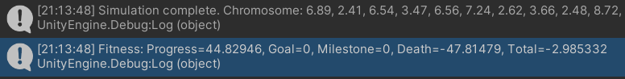

Simulation complete. Chromosome: 6.89, 2.41, 6.54, 3.47, 6.56, 7.24, 2.62, 3.66, 2.48, 8.72, 0.73, 0.11, 0.21, 6.34, 0.58, 1.07, 6.52, 6.71, 5.6, 3.86, 2.18, 9.44, 0.28, 0.1, 7.86, 0.94, 6.45, 4.14, 2.14, 6.48, 2.61, 5.81, 3.76, 3.43, 9.24, 2.25, 6.46, 3.55, 4.28, 7.66, 9.53, 3.21, 5.35, 3.97, 1.58, 2.36, 8.42, 4.33, 5.63, 6.36, 7.34, 8.86, 3.28, 7.88, 6.51, 2.72, 8.6, 1.49, 8.57, 0.2

After 3 Generations the AI can be seen getting much further in the level



Figure 6: Genetic Algorithm Generation 3 Individual 30



Simulation complete. Chromosome: 4.68, 6.71, 0.75, 6.23, 3.37, 9.21, 5.29, 3.74, 0.05, 0, 9.9, 0.07, 6.74, 8.53, 8.54, 0.52, 3.79, 0.32, 1.38, 10.7, 8.61, 6.94, 6.16, 8.56, 8.1, -0.93, 4.7, 1.98, 2.91, 5.65, 1.19, 7.06, 6.97, 4.05, 2.04, 3.84, 7.99, 5.64, -0.31, 9.02, -1.21, 2.89, 8.04, 5.63, 5.38, 8.22, 8.01, 6.3, 7.49, 3.7, 2.82, 8.73, 0.95, 3.67, 1.69, 0.83, 0.41, 6.47, 0.78, 3.03

## Genetic Algorithm Replay Function Demonstration

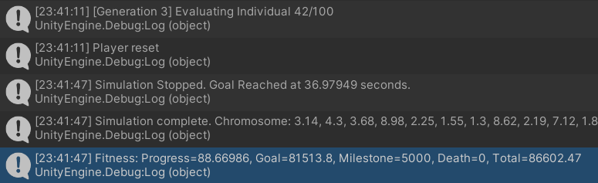

Simulation complete. Chromosome: 3.14, 4.3, 3.68, 8.98, 2.25, 1.55, 1.3, 8.62, 2.19, 7.12, 1.81, 0.05, 7.59, 1.11, 2.53, 5.9, 7.61, 7.84, 3.76, 1.57, 8.51, -0.09, 5.95, 9.2, 0.58, 4.19, 5.46, 0.98, 7.86, 0.33, 4.55, 6.72, 3.79, 0.99, 7.64, 4.25, 7, 4.79, 2.33, 0.03, 6.77, 6.1, 0.18, 7.21, 7.52, 7.81, 2.33, 7.15, 0.7, 5.06, 7.73, 2.47, 9.29, 0.67, 5.25, 6.19, 5.02, 5.41, 9.68, 3.08



Very close but not quite, I added an extra second to the 8th value of the chromosome and this one finished the level as expected

Simulation complete. Chromosome: 3.14, 4.3, 3.68, 8.98, 2.25, 1.55, 1.3, 9.62, 2.19, 7.12, 1.81, 0.05, 7.59, 1.11, 2.53, 5.9, 7.61, 7.84, 3.76, 1.57, 8.51, -0.09, 5.95, 9.2, 0.58, 4.19, 5.46, 0.98, 7.86, 0.33, 4.55, 6.72, 3.79, 0.99, 7.64, 4.25, 7, 4.79, 2.33, 0.03, 6.77, 6.1, 0.18, 7.21, 7.52, 7.81, 2.33, 7.15, 0.7, 5.06, 7.73, 2.47, 9.29, 0.67, 5.25, 6.19, 5.02, 5.41, 9.68, 3.08



### Other Complete Examples that wouldn’t replay quite right

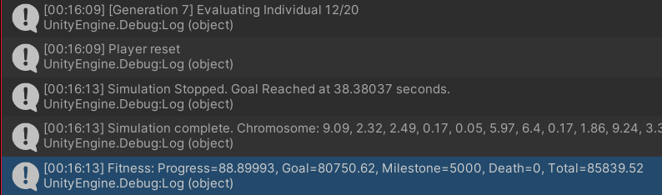

Simulation complete. Chromosome: 9.09, 2.32, 2.49, 0.17, 0.05, 5.97, 6.4, 0.17, 1.86, 9.24, 3.37, 6.68, 7.43, 1.83, 1.85, 0.47, 8.36, -0.43, 4.6, 0.89, 8.55, 9.32, 9.12, 9.95, 5.09, 6.78, 4.35, 2.18, 6.95, 3.13, 8.61, 1.78, 9.02, -0.18, -0.33, -0.07, 6.74, 10.95, 5.28, 2.97, 2.54, 4.78, -0.22, 8.22, 8.29, 1.24, 8.33, 7.27, 3.23, 8.31, 0.43, 5.38, 8.12, 9.67, 7.47, 1.14, 4.03, 3.33, 3.31, 2.1

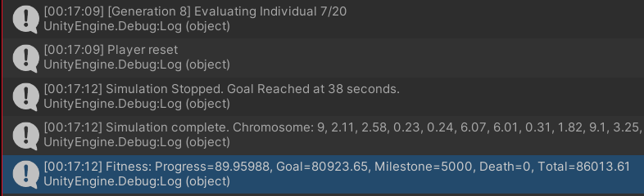

Simulation complete. Chromosome: 9, 2.11, 2.58, 0.23, 0.24, 6.07, 6.01, 0.31, 1.82, 9.1, 3.25, 6.66, 7.37, 1.95, 2.06, 0.54, 8.25, -0.39, 4.53, 0.93, 8.44, 9.64, 9.08, 9.77, 5.08, 6.68, 4.33, 2.29, 6.89, 3.09, 8.55, 1.91, 8.96, 0.24, -0.32, 0.07, 6.7, 10.88, 5.22, 3.45, 2.47, 4.72, -0.16, 8.2, 8.22, 1.3, 8.34, 7.33, 3.33, 8.2, 0.45, 5.58, 8.05, 9.66, 7.43, 1.12, 4.13, 3.27, 3.41, 2.2

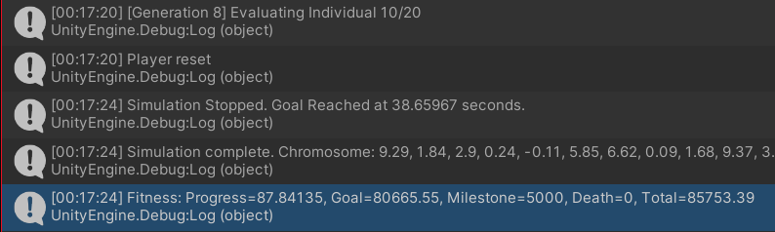

Simulation complete. Chromosome: 9.29, 1.84, 2.9, 0.24, -0.11, 5.85, 6.62, 0.09, 1.68, 9.37, 3.22, 6.75, 7.29, 1.39, 1.35, 0.29, 8.57, -1.07, 4.74, 0.89, 9.02, 9.2, 9.22, 10.21, 5.08, 6.69, 4.34, 1.87, 6.87, 2.98, 8.23, 1.39, 9.14, -0.62, -0.57, -0.38, 6.84, 11.34, 5.46, 2.76, 2.54, 4.88, -0.14, 8.62, 8.9, 1.08, 7.97, 7.53, 3.04, 8.49, 0.39, 6.28, 8.32, 9.73, 7.68, 0.81, 3.73, 2.88, 3.34, 1.88

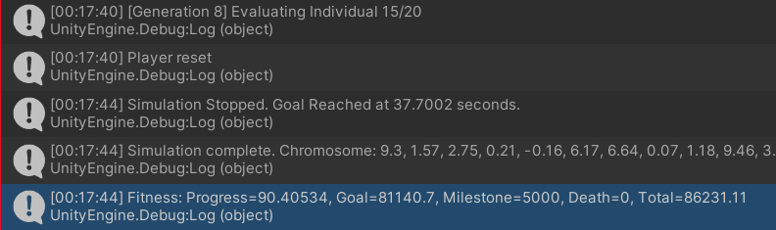

Simulation complete. Chromosome: 9.3, 1.57, 2.75, 0.21, -0.16, 6.17, 6.64, 0.07, 1.18, 9.46, 3.21, 6.75, 7.29, 1.37, 1.45, 0.29, 8.53, -1.03, 4.73, 0.86, 8.95, 9.24, 9.22, 10.26, 5.09, 7.2, 4.36, 1.75, 6.89, 3.22, 8.24, 1.35, 9.11, -0.59, -0.55, -0.4, 6.85, 11.33, 5.21, 2.76, 2.54, 4.9, -0.09, 8.26, 8.24, 1.07, 8.45, 7.57, 3.03, 8.49, 0.33, 5.81, 8.31, 9.73, 7.69, 1.05, 3.73, 3.18, 3.22, 1.95

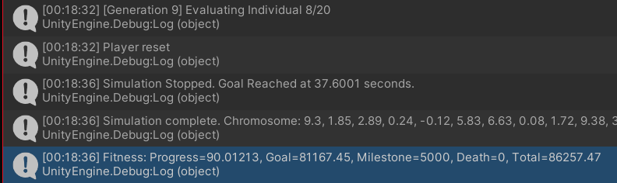

Simulation complete. Chromosome: 9.3, 1.85, 2.89, 0.24, -0.12, 5.83, 6.63, 0.08, 1.72, 9.38, 3.22, 6.75, 7.29, 1.38, 1.35, 0.29, 8.58, -1.07, 4.92, 0.89, 9.02, 9.21, 9.22, 10.21, 5.09, 6.51, 4.34, 1.86, 6.89, 2.97, 8.23, 1.38, 9.15, -0.9, -0.57, -0.39, 6.62, 11.33, 5.48, 2.76, 2.54, 4.88, -0.15, 8.65, 8.94, 1.08, 7.96, 7.53, 3.04, 8.44, 0.4, 6.24, 8.32, 9.68, 7.68, 0.79, 3.73, 2.87, 3.33, 1.98

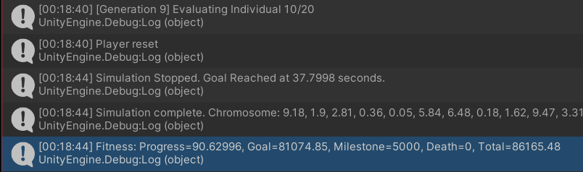

Simulation complete. Chromosome: 9.18, 1.9, 2.81, 0.36, 0.05, 5.84, 6.48, 0.18, 1.62, 9.47, 3.31, 6.7, 7.32, 1.59, 1.55, 0.39, 8.45, -0.86, 4.67, 1.02, 8.82, 9.12, 9.06, 9.98, 4.97, 6.65, 4.34, 1.99, 6.82, 2.99, 8.29, 1.58, 9.08, -0.45, -0.5, -0.22, 6.81, 11.23, 5.44, 2.94, 2.51, 4.81, -0.14, 8.51, 8.68, 1.11, 8.05, 7.34, 3.16, 8.37, 0.44, 6.03, 8.22, 9.67, 7.59, 0.89, 3.61, 2.97, 3.4, 1.94

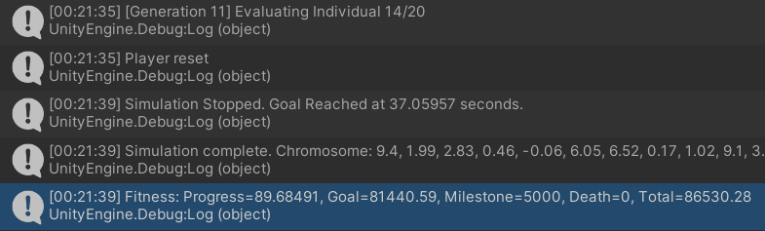

Simulation complete. Chromosome: 9.4, 1.99, 2.83, 0.46, -0.06, 6.05, 6.52, 0.17, 1.02, 9.1, 3.28, 6.7, 7.34, 1.6, 1.48, 0.38, 8.42, -0.88, 4.69, 0.89, 9.08, 9.13, 9.21, 10.11, 5.08, 6.43, 4.33, 1.98, 6.78, 3.15, 8.42, 1.7, 9.16, -0.48, -0.39, -0.26, 7.16, 11.21, 5.63, 2.84, 2.35, 4.84, -0.17, 8.29, 8.76, 1.22, 8.06, 7.26, 3.39, 8.39, 0.39, 6.17, 8.3, 9.7, 7.6, 0.98, 3.76, 3.05, 3.39, 2.1

# Conclusion

Although the genetic algorithm playing the 2D platformer level was often inconsistent, as a proof of concept this demonstration was a success and displayed an understanding of the genetic algorithm training process. This project demonstrated the improvement of a genetic algorithm in completing a level and showed a deep understanding of the chromosome created and how it represented a run of the game.

# List of Figures

Figure 1: Chromosome Example 5

Figure 2: Fitness Function, later death example 11

Figure 3: Best Chromosome with late death fitness 11

Figure 4: 2D Platformer Human Run 12

Figure 5: Genetic Algorithm Generation 1 Individual 20 14

Figure 6: Genetic Algorithm Generation 3 Individual 30 15

# References

Elsbury, B., 2025. *Billy-Elsbury/2D-Platformer-Unity*. Available at: <https://github.com/Billy-Elsbury/2D-Platformer-Unity> [Accessed 3 March 2025].

Hasan, 2025. *striderzz/2D-Platformer-Unity*. Available at: <https://github.com/striderzz/2D-Platformer-Unity> [Accessed 3 March 2025].

IronPython.net, 2025. *IronPython.net /*. [online] Available at: <https://ironpython.net/> [Accessed 3 March 2025].

Sheehy, R., 2025. *AI/2025 at main · Robert-Sheehy/AI*. [online] Available at: <https://github.com/Robert-Sheehy/AI/tree/main/2025> [Accessed 3 March 2025].

Unity3d.com, 2025. *Python Scripting | Python Scripting | 6.0.1*. [online] Available at: <https://docs.unity3d.com/Packages/com.unity.scripting.python@6.0/manual/index.html> [Accessed 3 March 2025].

Unknown, 2013. Tech Art Survival Guide: Embedding IronPython in Unity = Tech-art hog heaven. *Tech Art Survival Guide*. Available at: <https://techartsurvival.blogspot.com/2013/12/embedding-ironpython-in-unity-tech-art.html> [Accessed 3 March 2025].